**OpenCV**

Version 1.0

e-con Systems

4/6/2018

Command Line Application User Manual

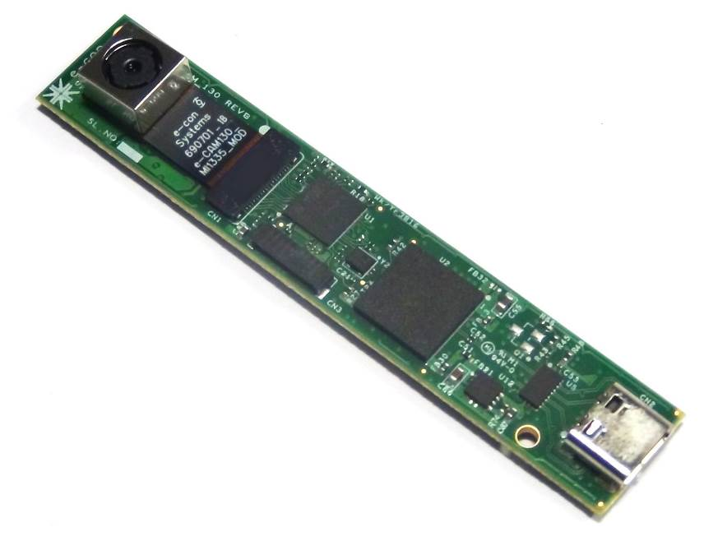



**Disclaimer**

The specifications of OpenCV command line application and instructions on how to run this with our e-con Systems camera are provided as reference only and e-con Systems reserves the right to edit/modify this document without any prior intimation of whatsoever.

Contents

Introduction to Sample Application 4

Prerequisites 4

Camera Device Initialization 4

Description 4

Launching the Application 5

Launching Windows Sample Application 5

Launching Linux Sample Application 5

Using Sample Application 6

Selecting the Camera Devices 6

Configuring Camera Formats or Resolutions 6

Setting Preview Format 7

Configuring UVC Settings 8

Capturing Still Image 10

Getting Firmware Version Number 10

Exiting the Application 11

Troubleshooting 12

Support 13

Introduction to Sample Application

e-con Systems provides a sample console application for OpenCV to demonstrate some of the features of e-con Systems cameras.

This document explains in detail about how to execute the OpenCV sample console application from command prompt on Windows and terminal on Linux platform.

Prerequisites

You must install OpenCV on a PC. Please refer to the *Installation Manual* for more detailed installation steps and images.

Camera Device Initialization

The steps to initialize the device with the host computer are as follows:

1. Connect the one end of USB 3.0 cable to the USB 3.0 connector provided at the back of e-con Systems camera.
2. Connect the other end of USB 3.0 cable to the USB 3.0 host controller on the computer. The device takes about 10 seconds to enumerate.

Once the device is connected, the LED light on the device will glow indicating that the camera is powered up and ready to use.

Description

Using OpenCV application, you can perform the features as follows:

* Selecting the camera devices.
* Configuring camera formats or resolutions.
* Setting preview formats.
* Configuring UVC settings.
* Capturing still images.
* Getting the firmware version number.

Launching the Application

This section describes how to launch and use the sample console application.Launching Windows Sample Application

To launch the Windows sample application, you must **run** the **<application**>**.exe** file. Select the application.exe file from the application root folder as shown below.

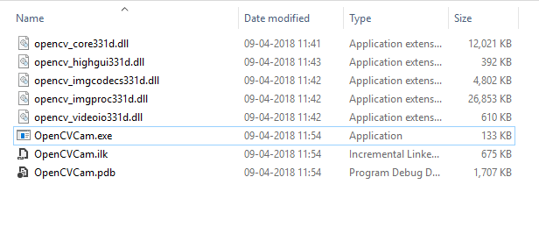

Figure 1: Windows Application Launch

Launching Linux Sample Application

Run the following command from the sample application folder using terminal.

$ sudo ./OpenCVCam

The screen appears as shown below.

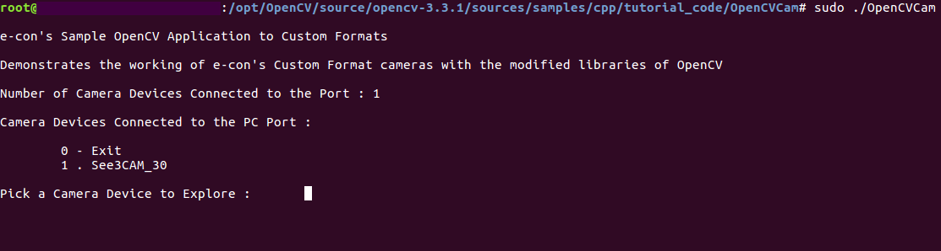

Figure 2: Linux Application Launch

This version of OpenCV sample application is provided with a set of features that can be used to attain the certain functionality of e-con Systems cameras such as camera video formats, resolution, UVC controls, capturing still images and reading firmware version number. OpenCV sample application will list the number of cameras connected to the port.

Using Sample Application

This section describes the features supported in OpenCV application.

Selecting the Camera Devices

Initially, the command line application displays the number of cameras connected to the PC. The Camera Names, Vendor ID, Product ID and Device Path will also be displayed.

You must select the Camera Device to explore their features using this command line application and the preview will be displayed parallelly as shown below.

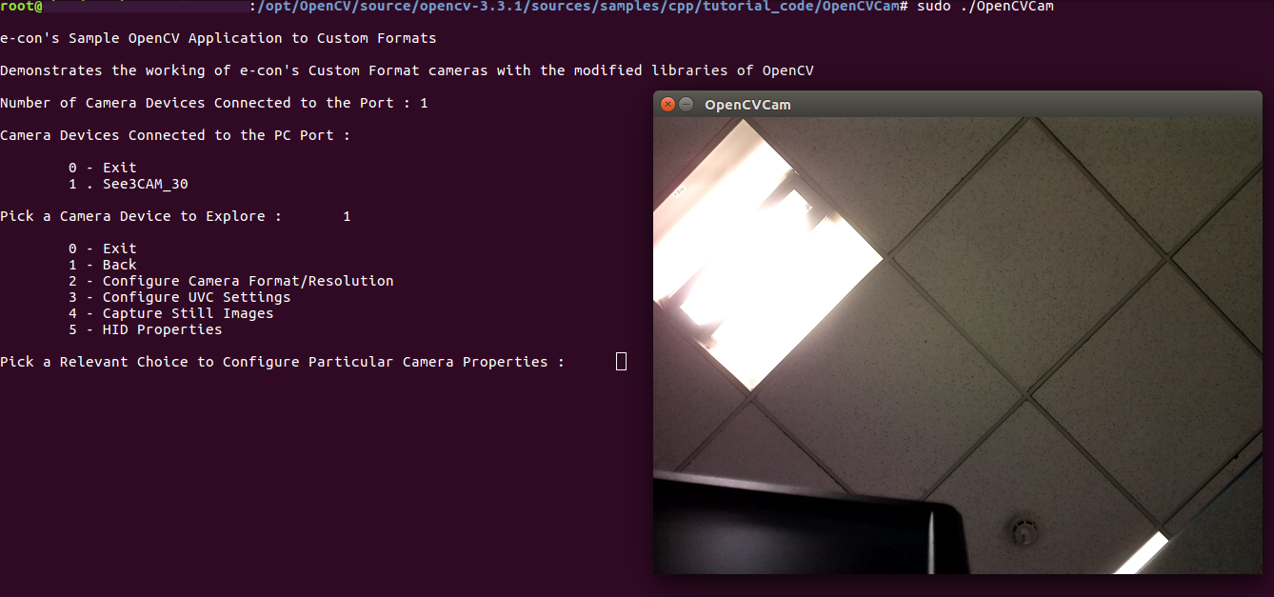

Figure 3: Camera Device Configuration

Configuring Camera Formats or Resolutions

The steps to explore camera format or resolution are as follows:

1. Enter **2** in **Pick a Relevant Choice to Configure Particular Camera Properties** to configure camera format or resolution. The format or resolution supported by the camera will be listed as shown below.

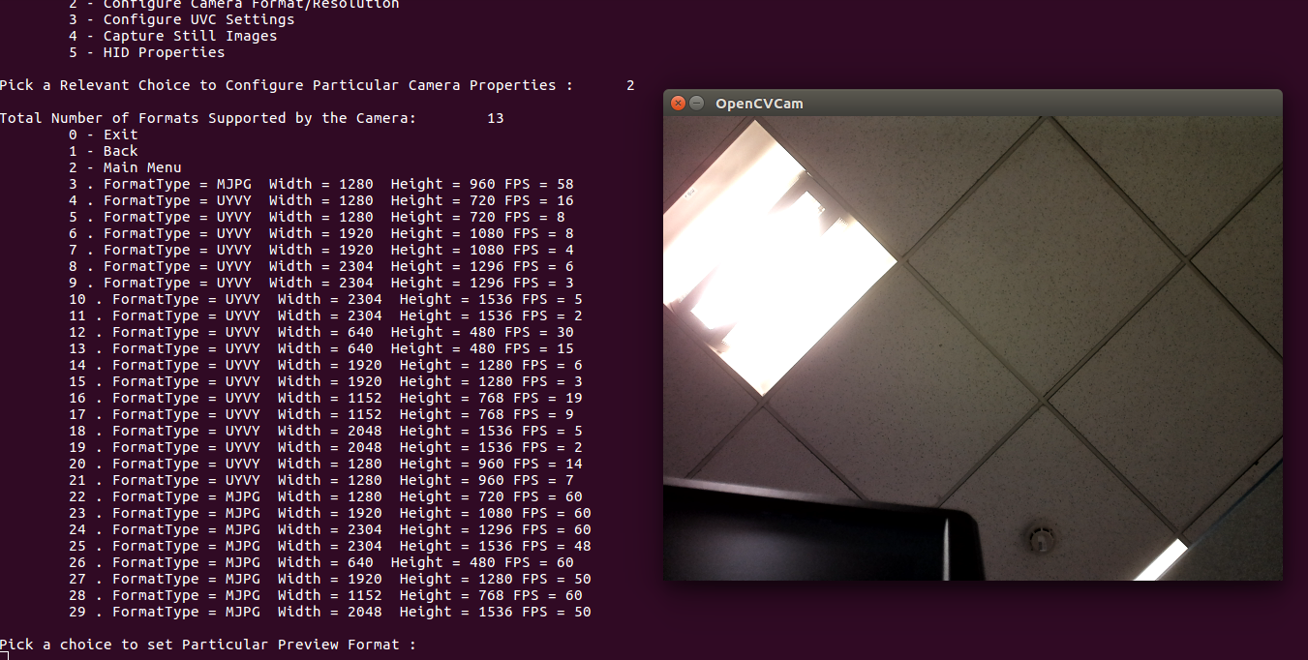

Figure 4: Camera Formats or Resolution

1. Select the format or resolution type and the preview will be changed as shown below.

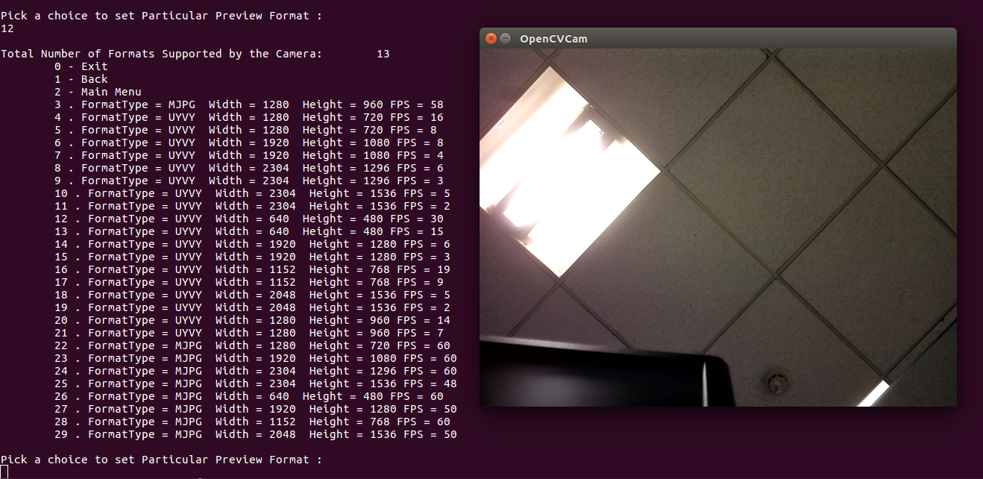

Figure 5: Formats or Resolution Configuration

Setting Preview Format

You can set the preview format using the following options:

* Option **0** to exit from the application.
* Option **1** to go back to the previous menu.
* Option **2** to configure camera format or resolution.
* Option **3** to configure UVC settings.
* Option **4** to capture still images.
* Option **5** to go to HID properties.

Enter **1** in **Pick a choice to set Particular Preview Format** to set preview format as shown below.

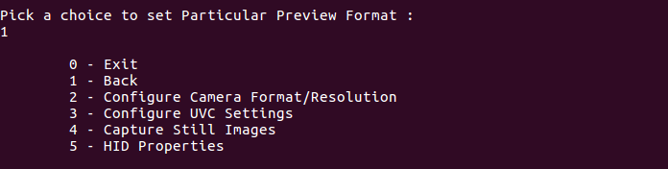

Figure 6: Setting Preview Format

Configuring UVC Settings

The steps to configure UVC settings are as follows:

1. Enter **3** in **Pick a Relevant Choice to Configure Particular Camera Properties** to configure UVC Settings. The supported UVC Settings will be displayed as shown below.

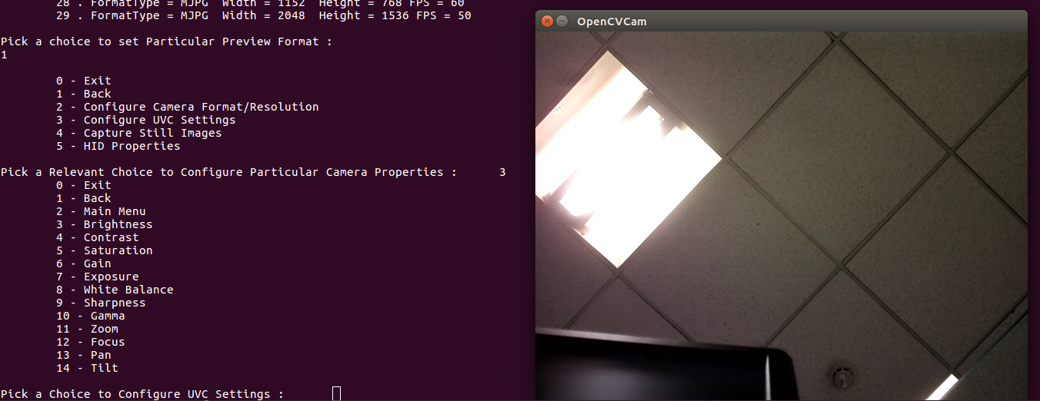

Figure 7: Configuring UVC Settings

2. Select a UVC Settings to modify the camera UVC property. For Brightness, you must enter **3** in **Pick a Choice to Configure UVC Settings**. The modes supported in camera are as follows:

* + If the camera supports manual mode, it will display minimum value, maximum value, stepping delta, current value, default value, current mode as manual and supported mode as manual.
  + If the camera supports Auto mode, it will display supported mode as Auto and current mode as Auto.
  + If the camera supports both auto and manual mode, it will display minimum value, maximum value, current value, default value, stepping delta, current mode and supported mode as Auto or Manual as shown below.

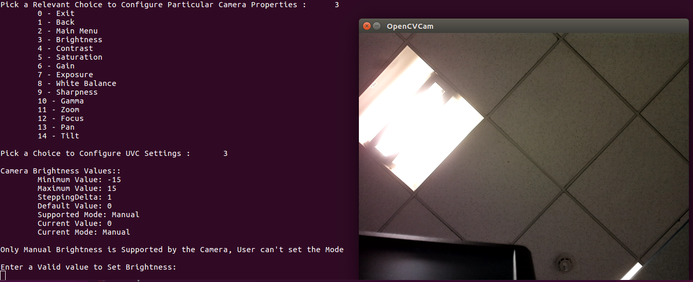

Figure 8: Setting Camera Brightness Values

To set Brightness, the value should satisfy the following conditions.

* + Value must be greater than or equal to minimum value.
  + Value must be lesser than or equal to maximum value.
  + Value must be divided by the stepping delta, that is , the stepping delta value must be equal to 0.

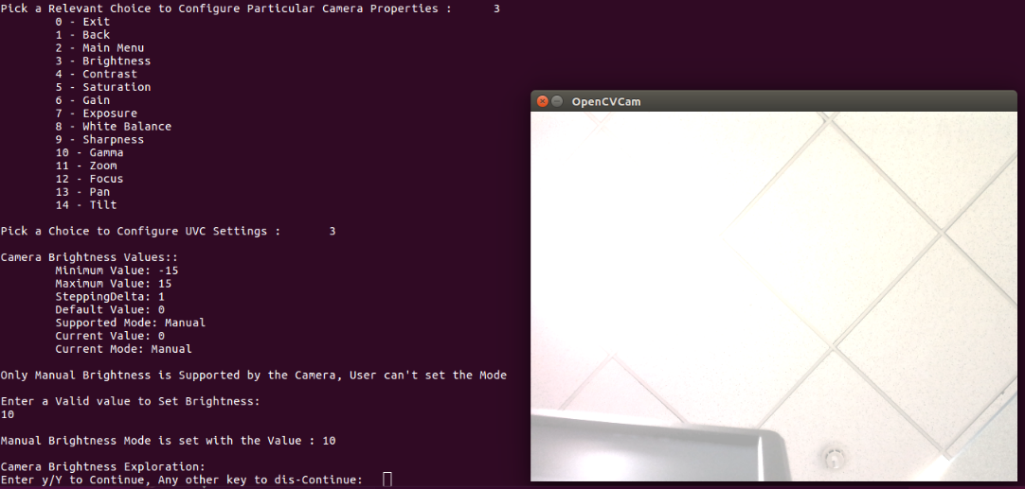

Figure 9: Brightness Configuration

1. You can enter **y/Y** to continue with changing the same property or **n** to go back to display the UVC settings supported by the camera and can change other camera UVC Properties as shown below.

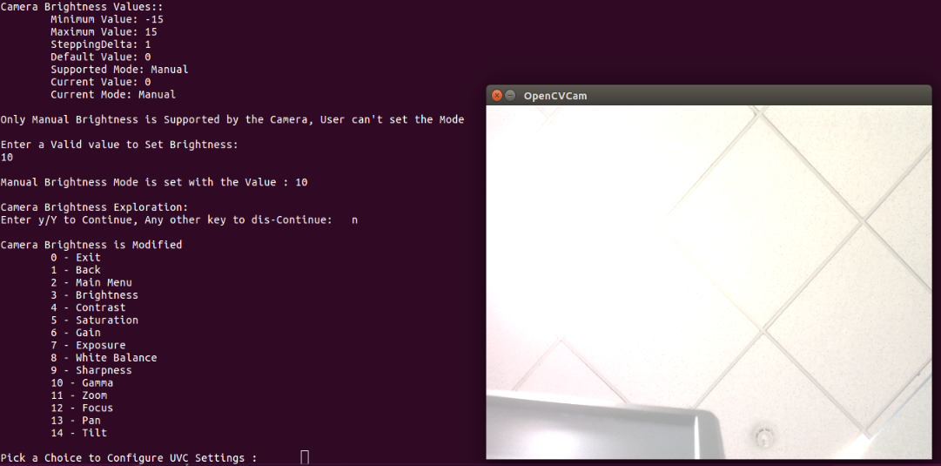

Figure 10: UVC Settings Menu Selection

Capturing Still Image

To capture the still image, you must enter **4** in **Pick a Relevant Choice to Configure Particular Camera Properties**. The image will be saved in the application root folder with the application name, system current date and time extensions as shown below.

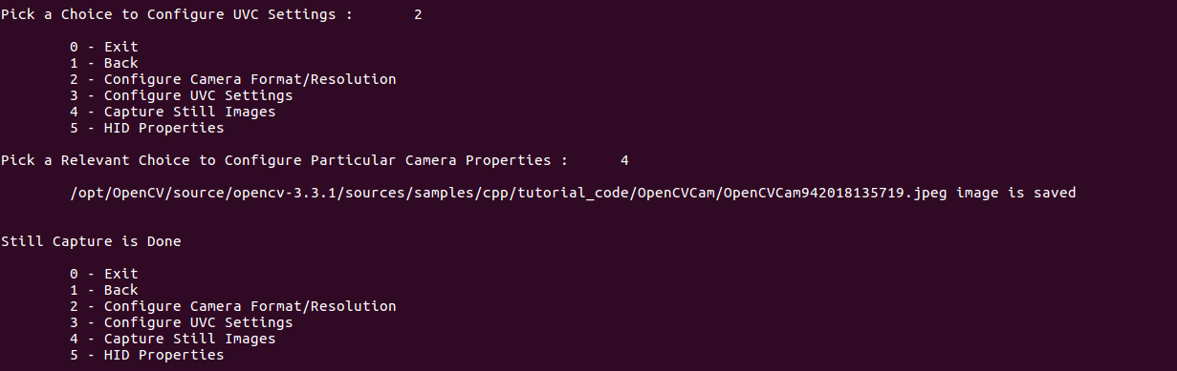

Figure 11: Capturing Still Image

Getting Firmware Version Number

You must enter **5** in **Pick a Relevant Choice to Configure Particular Camera Properties** to configure camera properties and enter **3** to get the firmware version number. The firmware version number will be displayed as shown below.

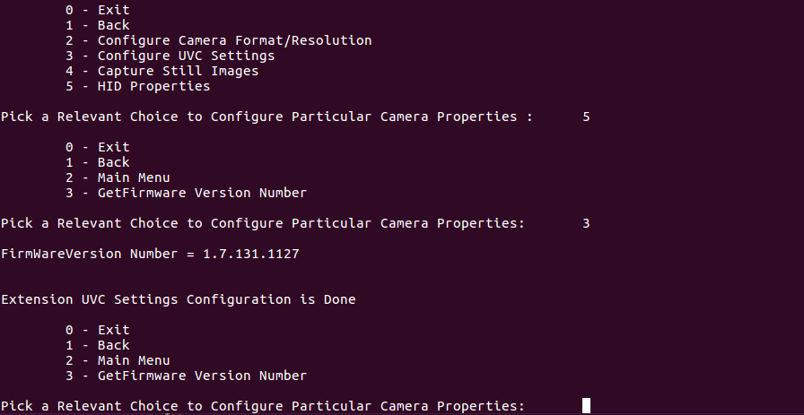

Figure 12: Getting Firmware Version Number

Exiting the Application

To exit the application, you must enter **0** in **Pick a Relevant Choice to Configure Particular Camera Properties** as shown below.

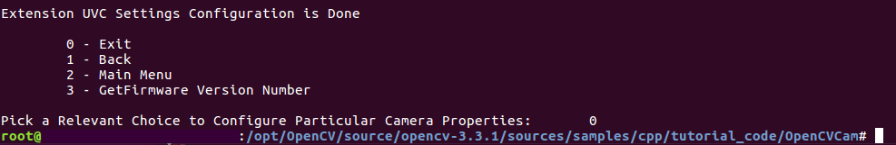

Figure 13: Exiting the Application

Troubleshooting

In this section, you can view the list of commonly occurring issues and their troubleshooting steps.

**Linux Issues**

**Camera device connected, but the application does not displayed.**

It seems like the camera is not properly detected by Linux, so check with the path **cd /sys/class/video4linux/** to detect the device.

**CMake Error: The source directory does not appear to contain CMakeLists.txt.**

1. Run cmake-gui command from the terminal to launch cmake.
2. Provide the source and release path of the OpenCV project.
3. Click configure to make the changes and generate for the solution.

**Compiling command line application, libudev.so error adding symbols, DSO missing from command line.**

You must include the -ludev dependency in the compilation command.

**Camera device displays in the command line but selecting the index does not end up with the preview.**

Make sure the camera connected to the port starts with video0 **/sys/class/video4linux**.

**Windows Issues**

**Linker issues relating to setupdi* while building.**

Add **setupapi.lib** in the modules/opencv_videoio properties tab under **Linker > input > Additional dependencies.**

**There is no install folder present in the opencv<version>/build/**

Build the CMakeTargets or Install project in both Debug and Release configurations.

Support

**Contact Us**

If you need any support on OpenCV Sample application, please contact us using the Live Chat option available on our website - <https://www.e-consystems.com/>

**Creating a Ticket**

If you need to create a ticket for any type of issue, please visit the ticketing page on our website - <https://www.e-consystems.com/create-ticket.asp>

**RMA**

To know about our Return Material Authorization (RMA) policy, please visit the RMA Policy page on our website - <https://www.e-consystems.com/RMA-Policy.asp>

**General Product Warranty Terms**

To know about our General Product Warranty Terms, please visit the General Warranty Terms page on our website - <https://www.e-consystems.com/warranty.asp>

Revision History

|  |  |  |  |
| --- | --- | --- | --- |
| Rev | Date | Description | Author |
| 1.0 | 10-April-2018 | Initial Draft | Chandra Sekar V |
|  |  |  |  |
|  |  |  |  |
|  |  |  |  |
|  |  |  |  |